1. Write a program to enter a string. Write following methods:

1.1- Returning the sum of characters (that are not space character) of the input string

Code

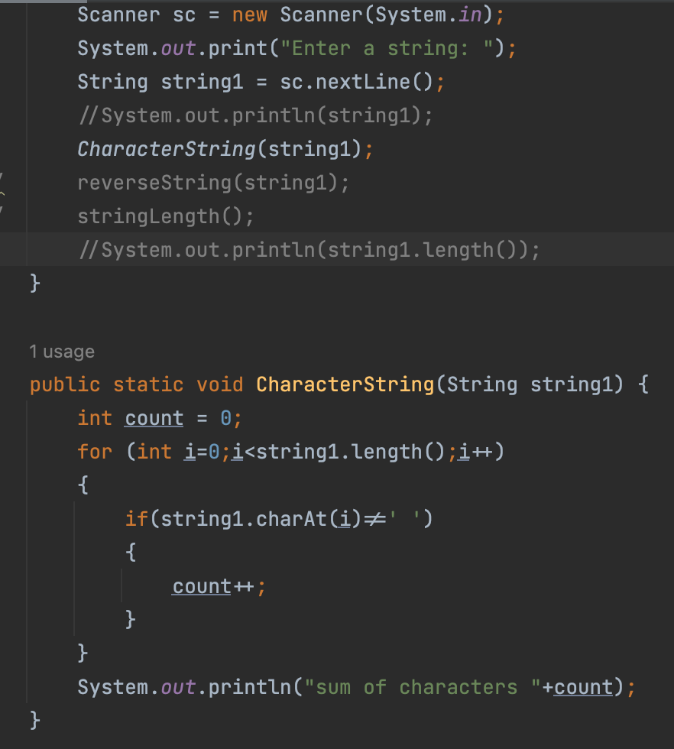

Result

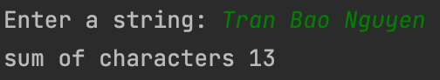

1.2 Print out the reserve string of the input string

Code

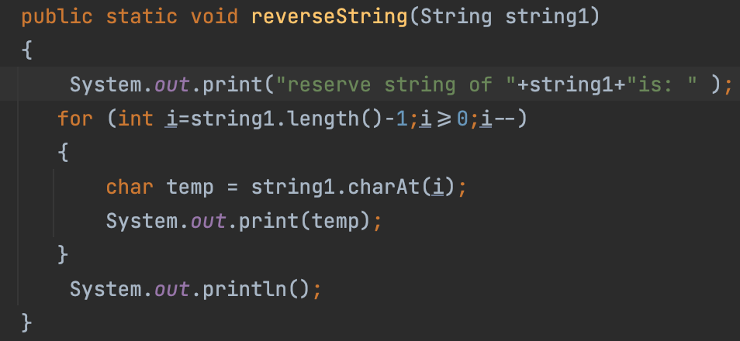

Result

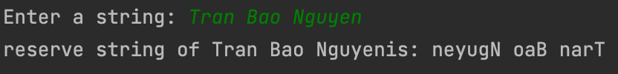

1.3 - If the string’s length > 3, print out the third character of the input string. Otherwise, print out to the console the message: “undefined”

Code

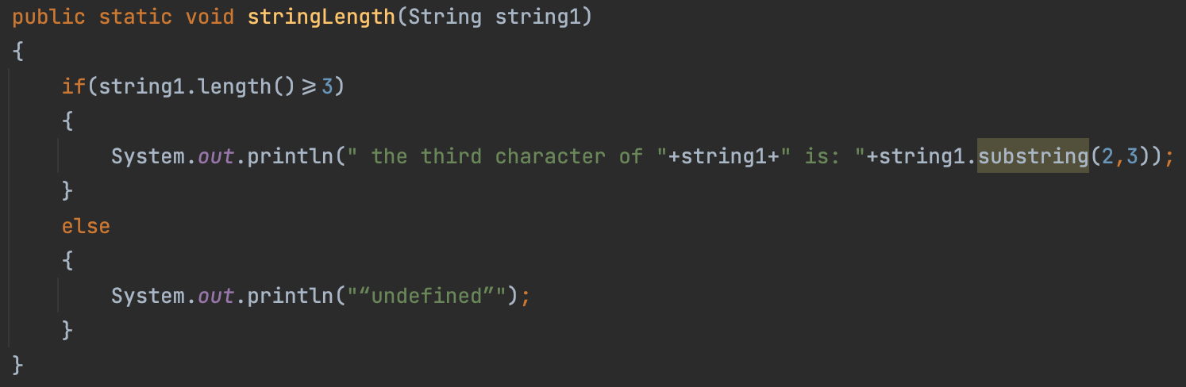

Result

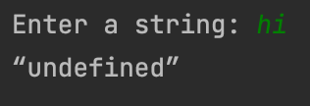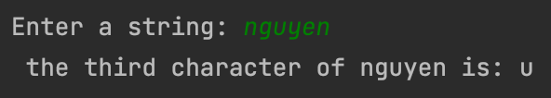

1.4Write an algorithm to accept two strings and check whether the second string exists within the first string.

Code

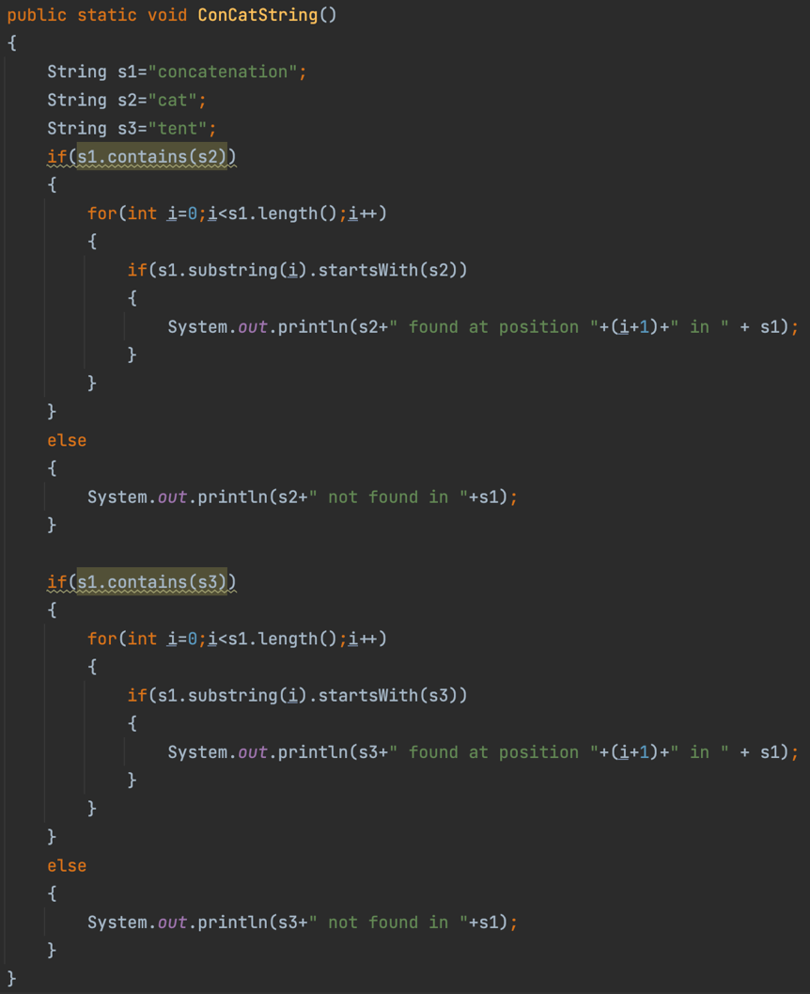

Result

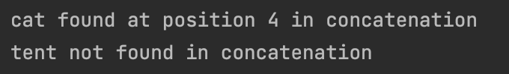

1.5 How many the numeral characters, the vowel characters, the consonant characters and the special characters does the input string have?

Code

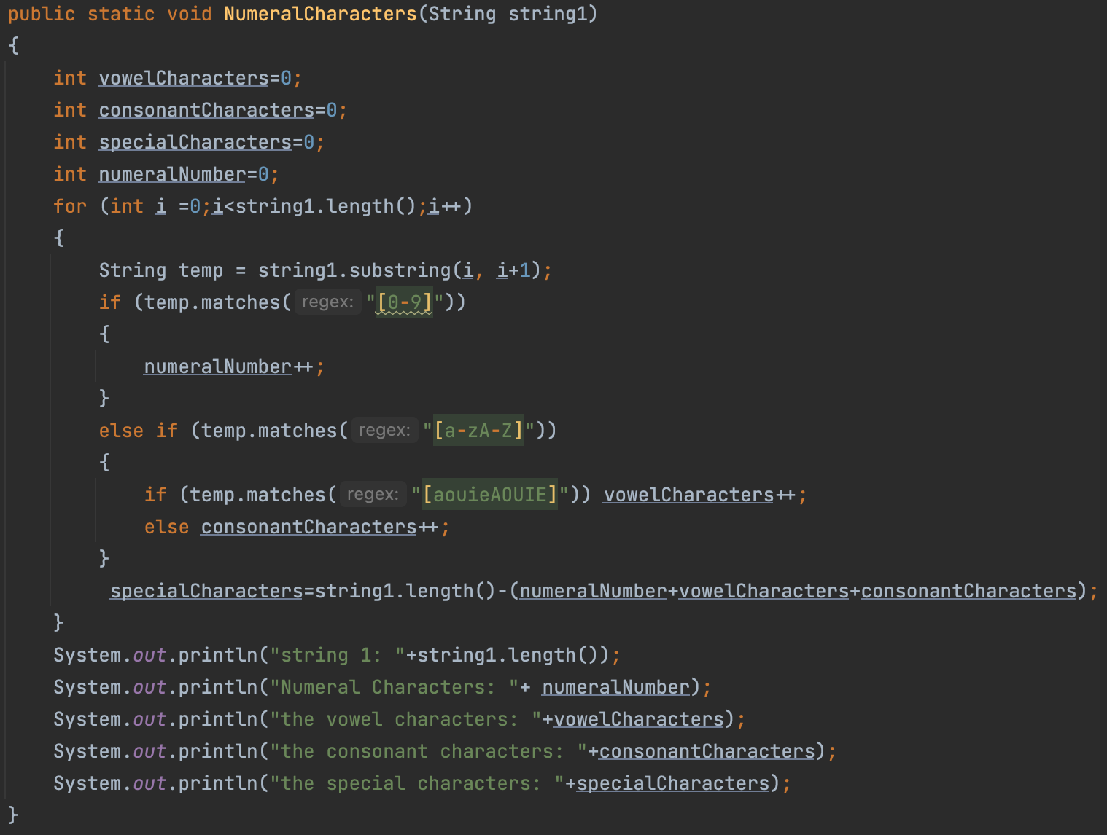

Result

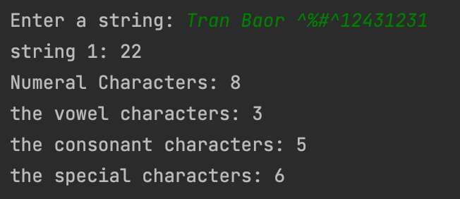

1.6 How many words in the input string?

Code

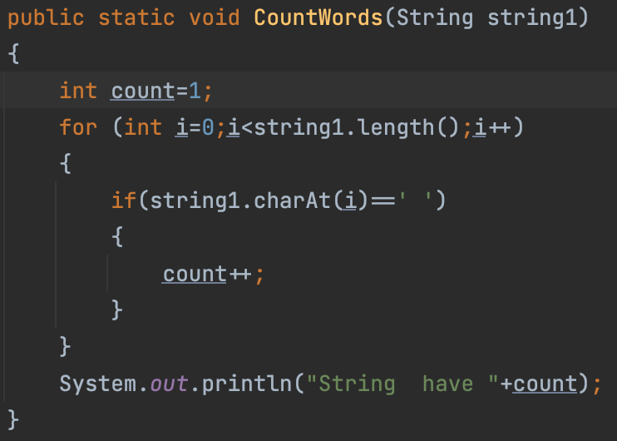

Result

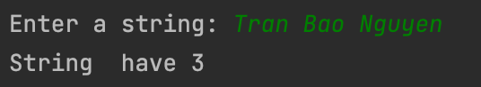

1.7+1.8 Print out the lower and upper case letters of input string

Code

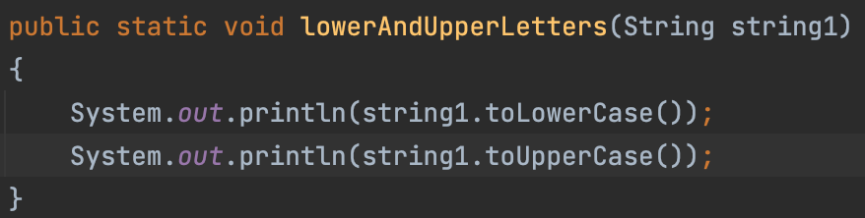

Result

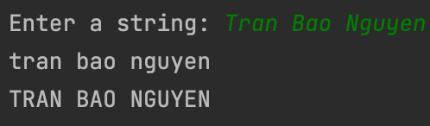

1.9 Replace letters that are identical and uninterrupted by one

Code

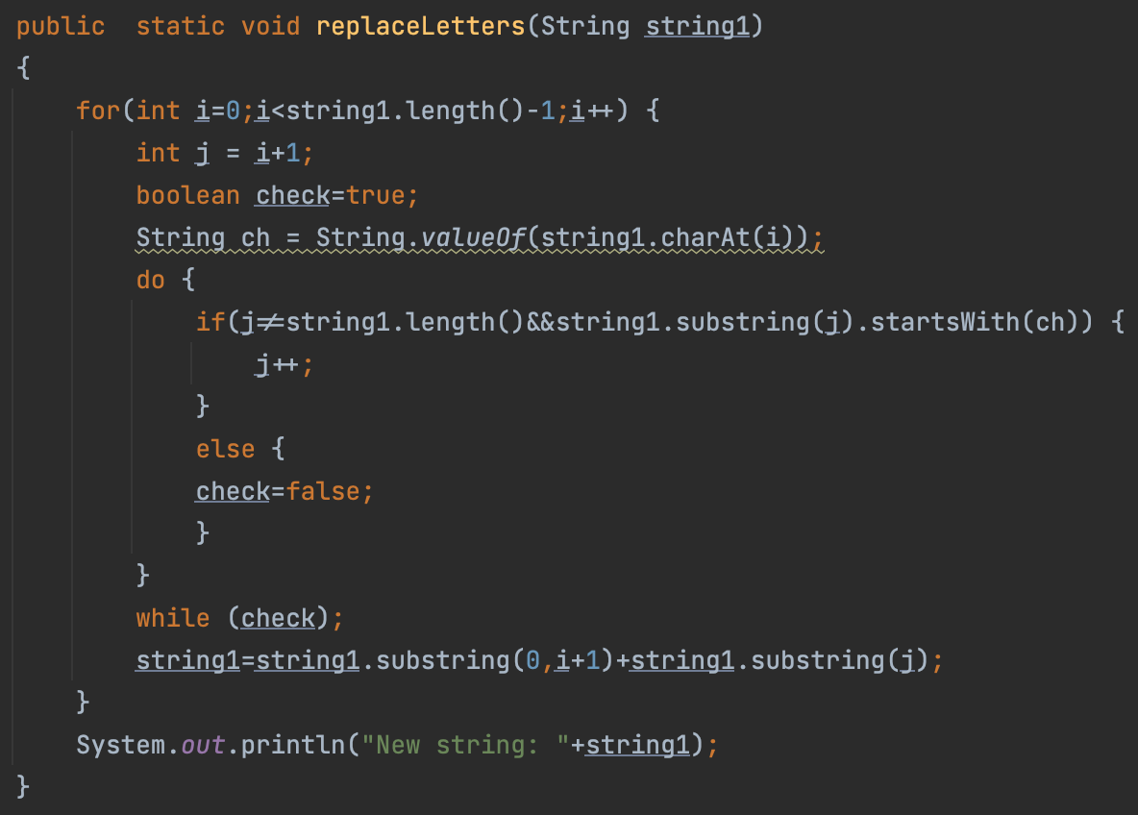

Result

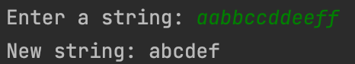

1.10 Create a method that input a string then all remove unnescessary blanks

Code

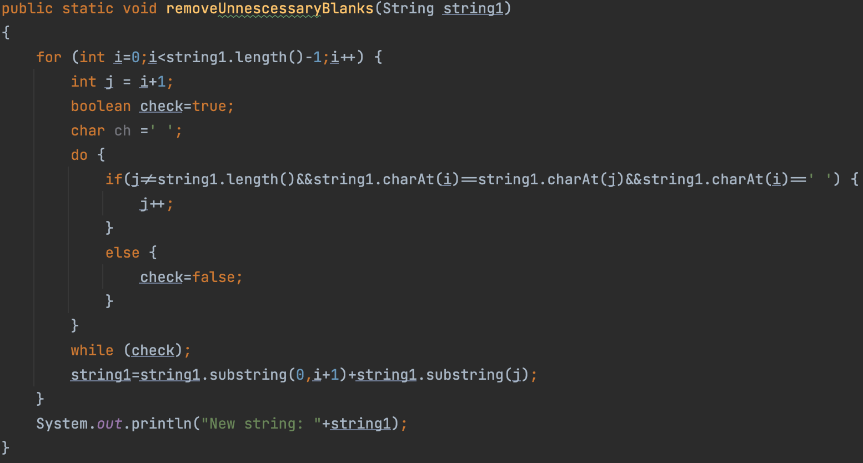

Result

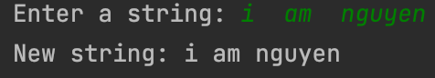

1.11 Create a method that input a string then count the number of presence of each letter

Code

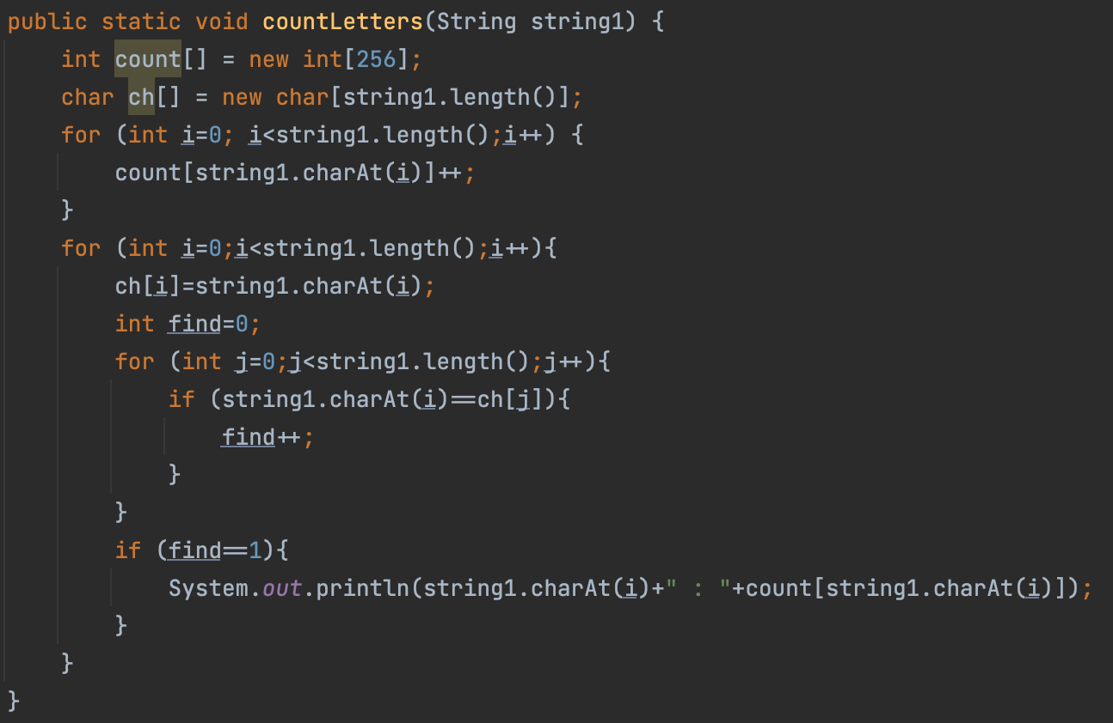

Result

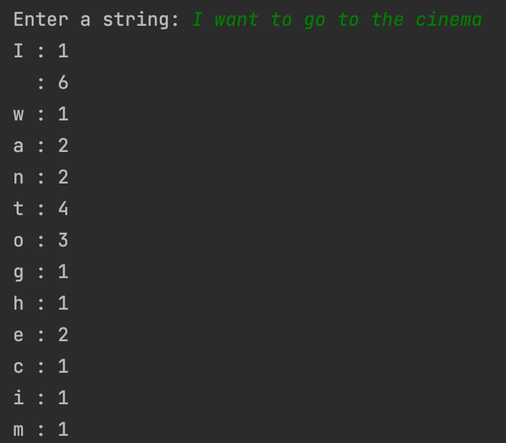

1.12 Create a method that convert an input to title case

Code

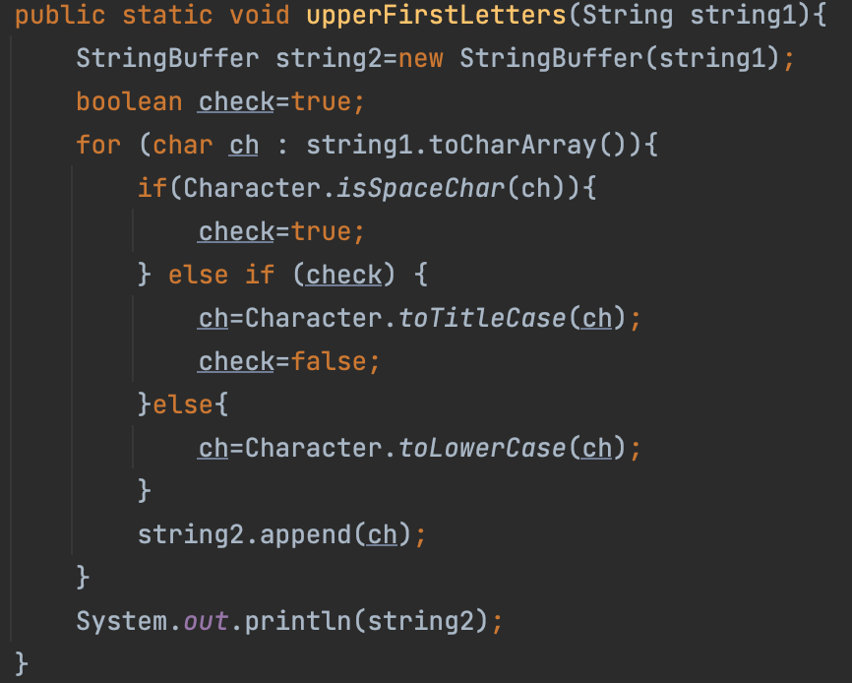

Result

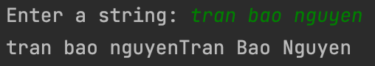

1.13 Create a method that convert an input to the English-name-like string

Code

2. Write a method that takes an ArrayList of Strings as a parameter and that removes all of the strings of even length from the list.

Code

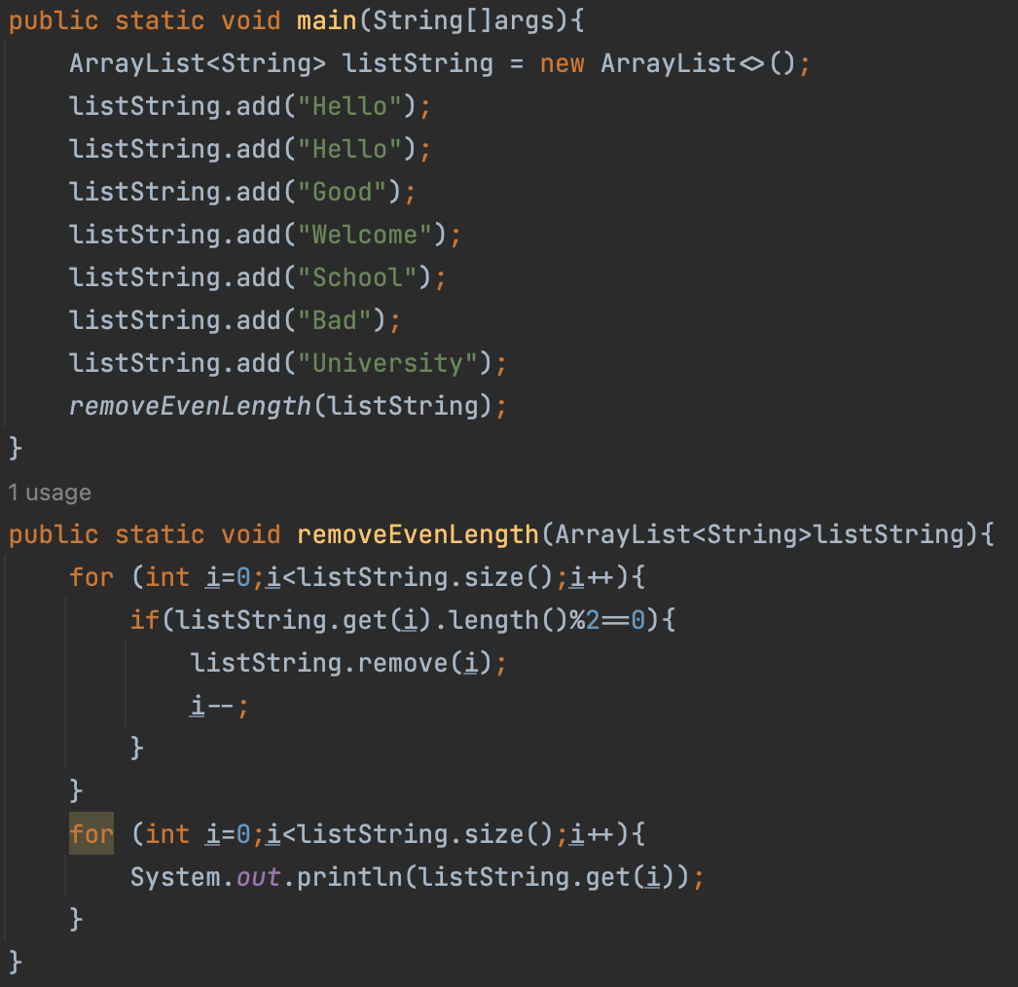

Result

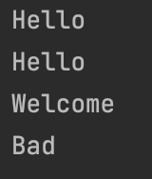

3. Write a method that takes a Set of strings as a parameter and that removes all of the strings of even length from the set. For example, if your method is passed a set containing the following elements:

Code

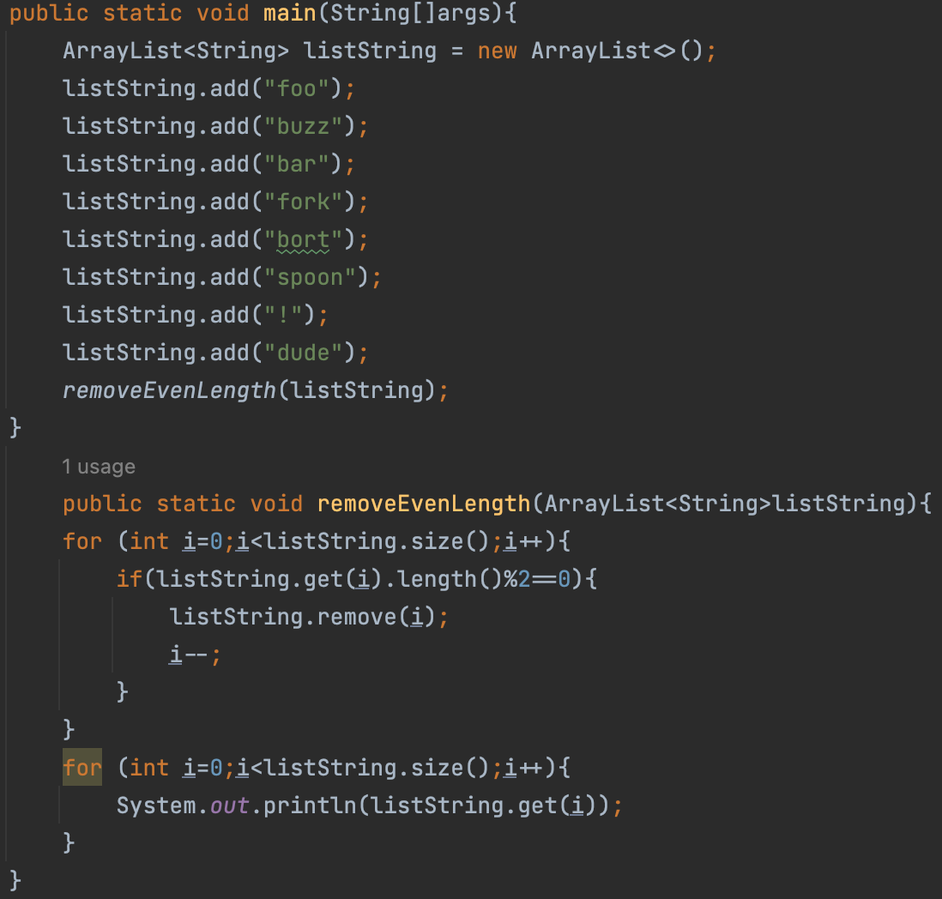

Result



4. Write a method that takes an ArrayList of Strings as a parameter and that replaces every string with two of that string.

Code

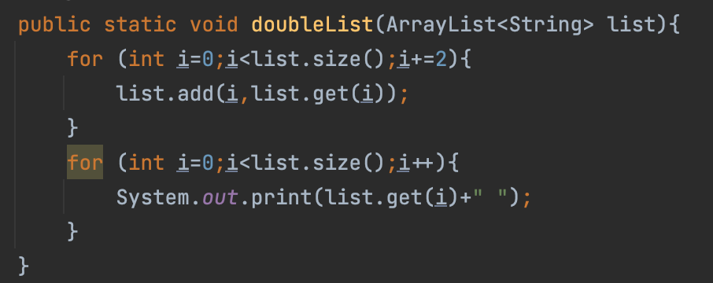

Result



5. Write a method that takes as a parameter a sorted ArrayList of Strings and that eliminates any duplicates from the list.

Code

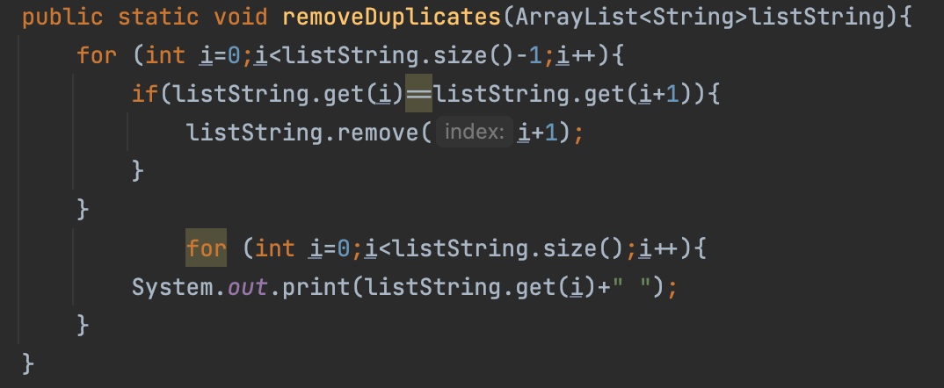

Result



6. Write a method that accepts a List of strings as a parameter and returns true if any single string occurs at least 3 times in the list, and false otherwise. Use a map as auxiliary storage.